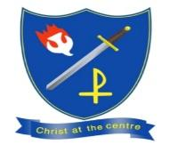
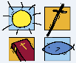
Key Vocabulary

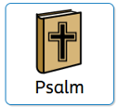Any holy hymn or lyrical poem addressed to a deity.
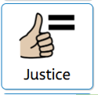 The quality of being fair and right
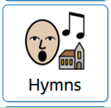 A song of praise, adoration, or prayer directed to God.
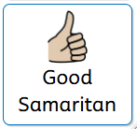 A famous story told by Jesus about choosing to help someone in need, even if they are a stranger or someone you do not get along

Branch Focus
Children meet the God who creates and calls a people. They study key figures in the Old Testament (such as Abraham and Moses), the Creation accounts in Genesis, and reflect on how we are called to care for God’s world and one another.
Big questions
Why did God create the world?

What does it mean to be a good steward of God’s world?

What is a covenant?• 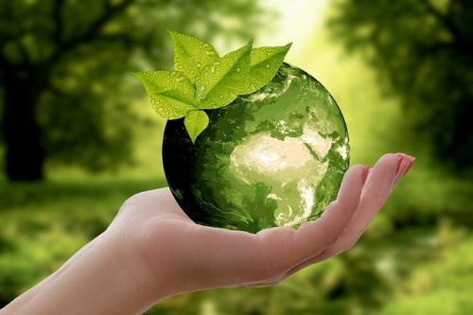

Bible Stories

• The First Creation Account (Genesis 1:1–2:3):
• The Call of Abram (Genesis 12:1–5): Introduces
• The Covenant and Promises (Genesis 15:1–6):]
• Reflective Scripture (Psalms, e.g., Psalm 19:1):
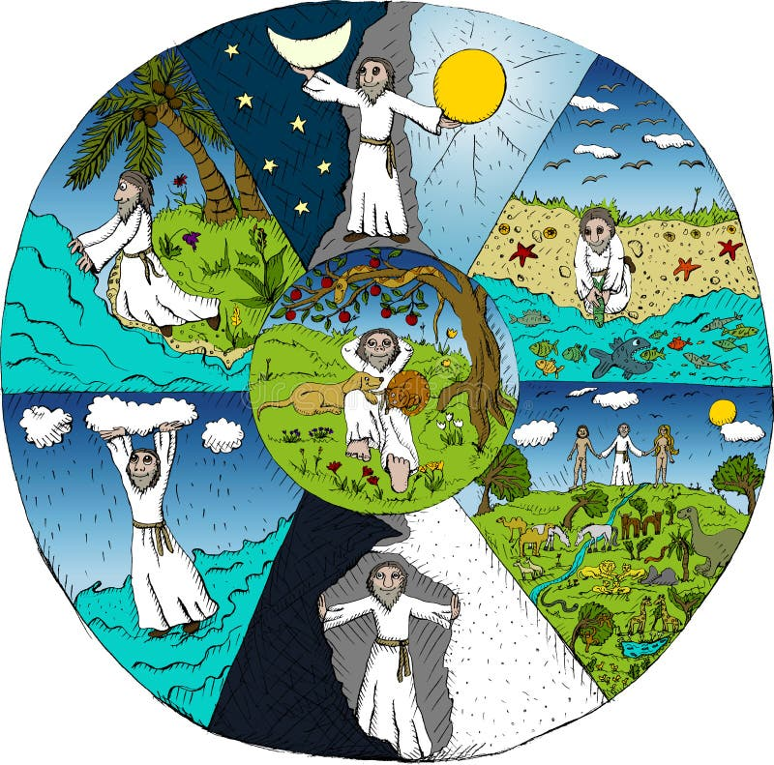

Sequence of learning
I can remember the repeated words in the Creation story and what these teach about God? | 1, 12
I can talk about what the belief that human beings are created in the image of God means. | 2, 12
I can reflect on the Christian belief that humans are created equal. | 3
I can make a link between the Creation story and human dignity. | 4, 12
I can describe some ways that Christians can keep a ‘holy’ day, and make a link to the story of the seventh day in the first story of Creation? | 5
I can recognise some Christian beliefs about Creation in Psalm 8. | 6, 12
I can talk about the meaning of the Canticle of Creation and wonder why Saint Francis’ wrote it. | 7
I can recognise that Laudato Si’ encourages people to love God, each other and the world. | 8, 12
I can describe ways that Christians can be stewards of Creation. | 9, 12
I can explain how some people care for the world to make a change for the better. | 10

Year 3
Religious Education Knowledge Organiser
Creation & Covenant
Autumn 1

