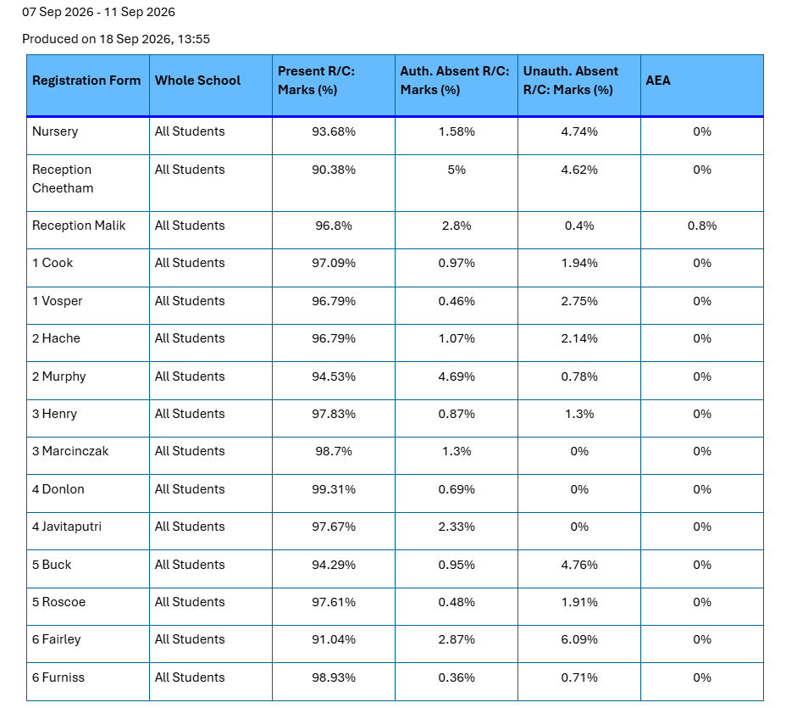
7 Sep – 11 Sep 2026

