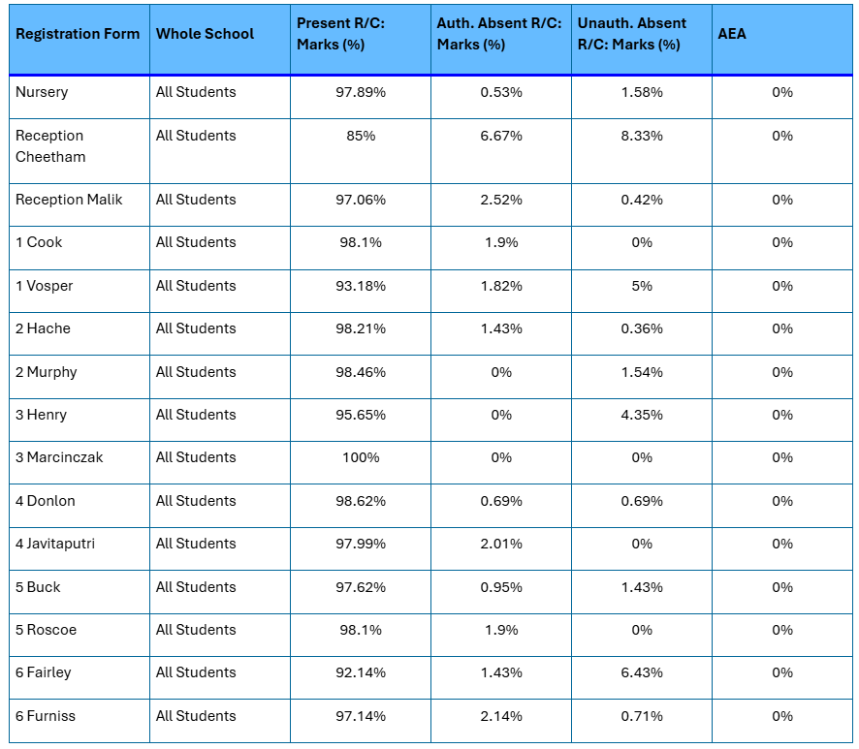
14 Sep – 18 Sep 2026

